Step 1 : Login Page

Login URL to WebApp: <https://rameshjatiya.com/myApp>

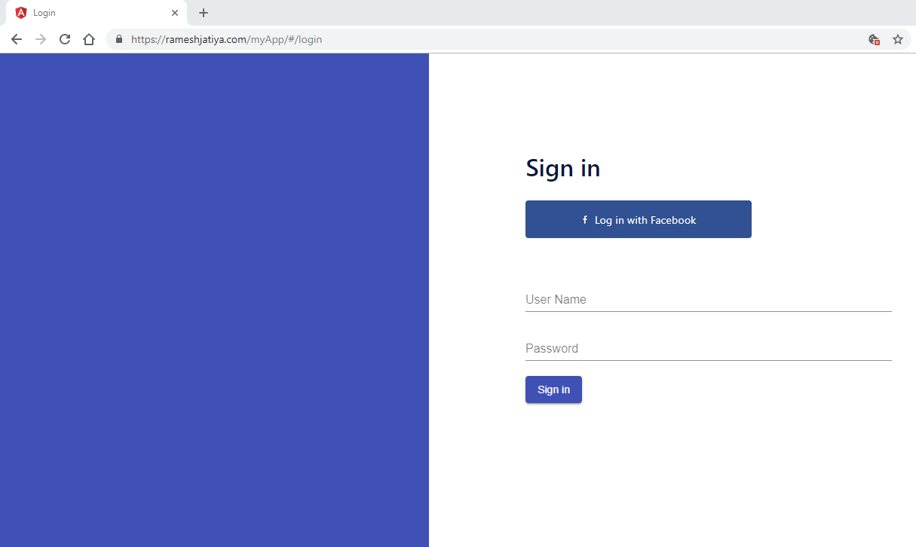

Step 2a): Facebook Login Popup if you are not login to same browser in another tab

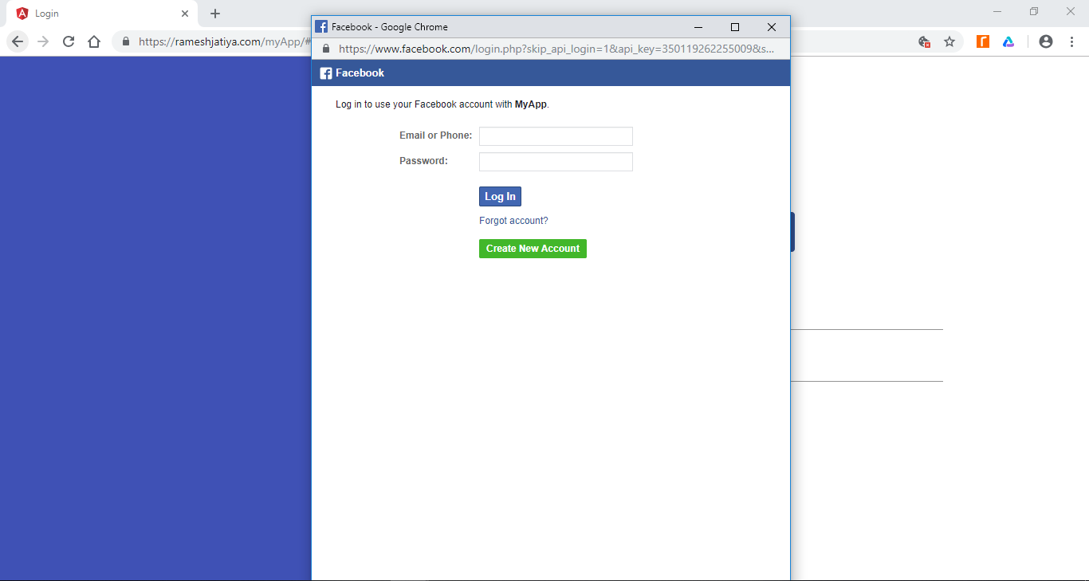

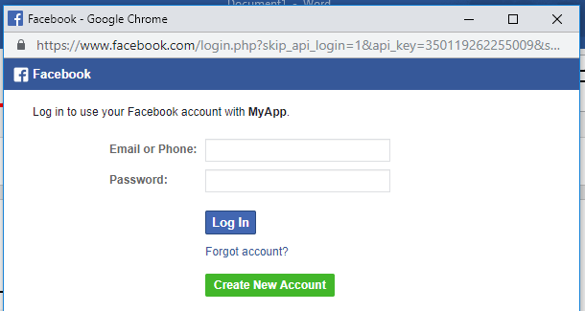

Step 2b): Facebook Login Popup if you are already login in another tab of same browser

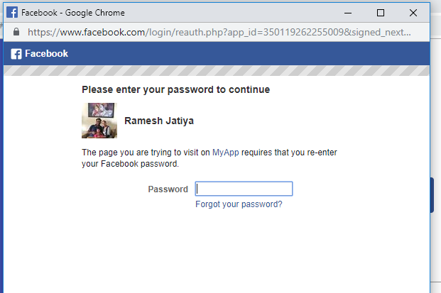

Step 3) Redirect to Welcome page on successful Login

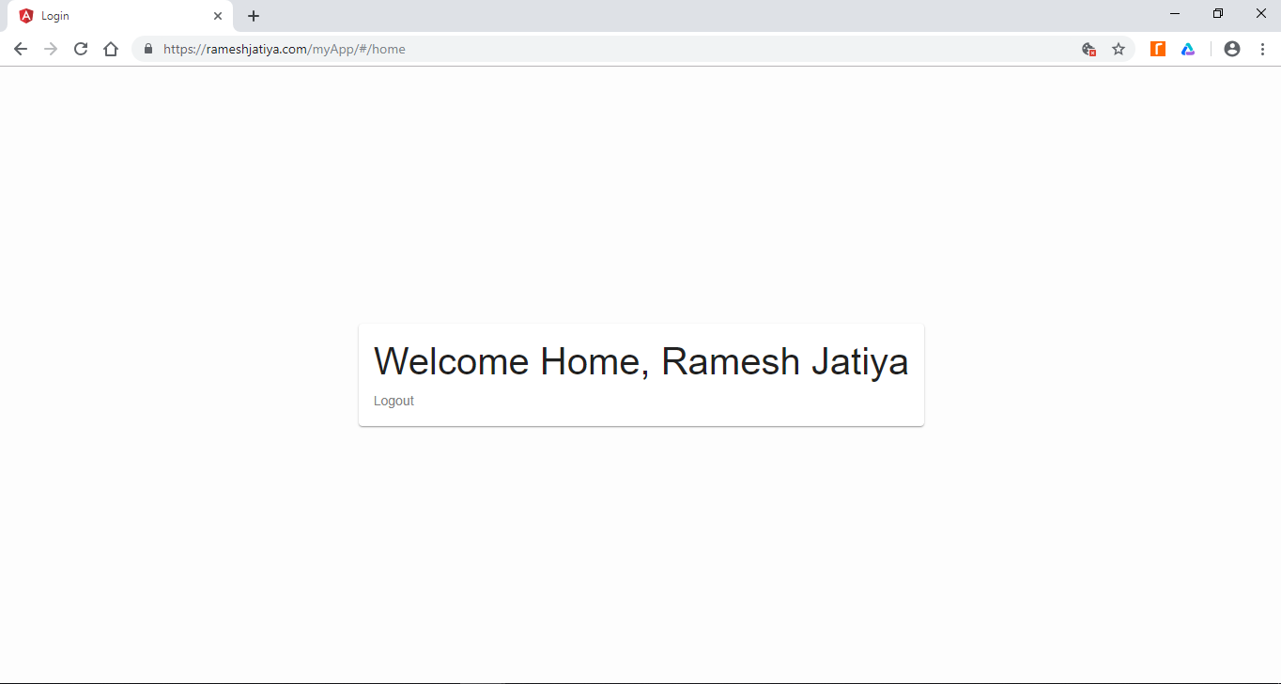

Step 4) Redirect back to lending page on click of Logout



Step 5) Login with Existing user without Facebook

Username: [ramesh@abc.com](mailto:ramesh@abc.com)

Password: 123456

